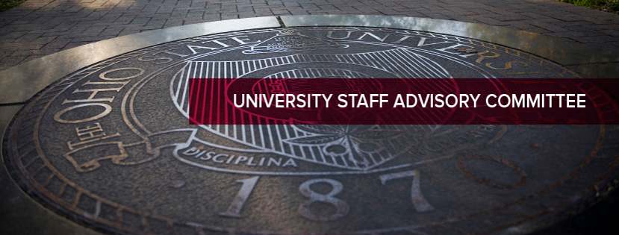

University Staff Advisory Committee (USAC) Business Meeting
Wednesday, September 27, 2023
2:30-4:30 p.m. – Ohio Union, 3rd Floor, Barbie Tootle room (also on Teams)

- Welcome
- Approve minutes from last business meeting.
- OSU Leadership Guests:
  - Katie Hall
- Erica Banta – OSU HR Digital Learning Team
- Executive Committee updates
- Update for Staff Grants from Casey Henceroth
- Report out from Staff Senators and Brandon Gibbs
- Concerns/Comments from Staff Guests
- Updates/Challenges/Opportunities from USAC Members

